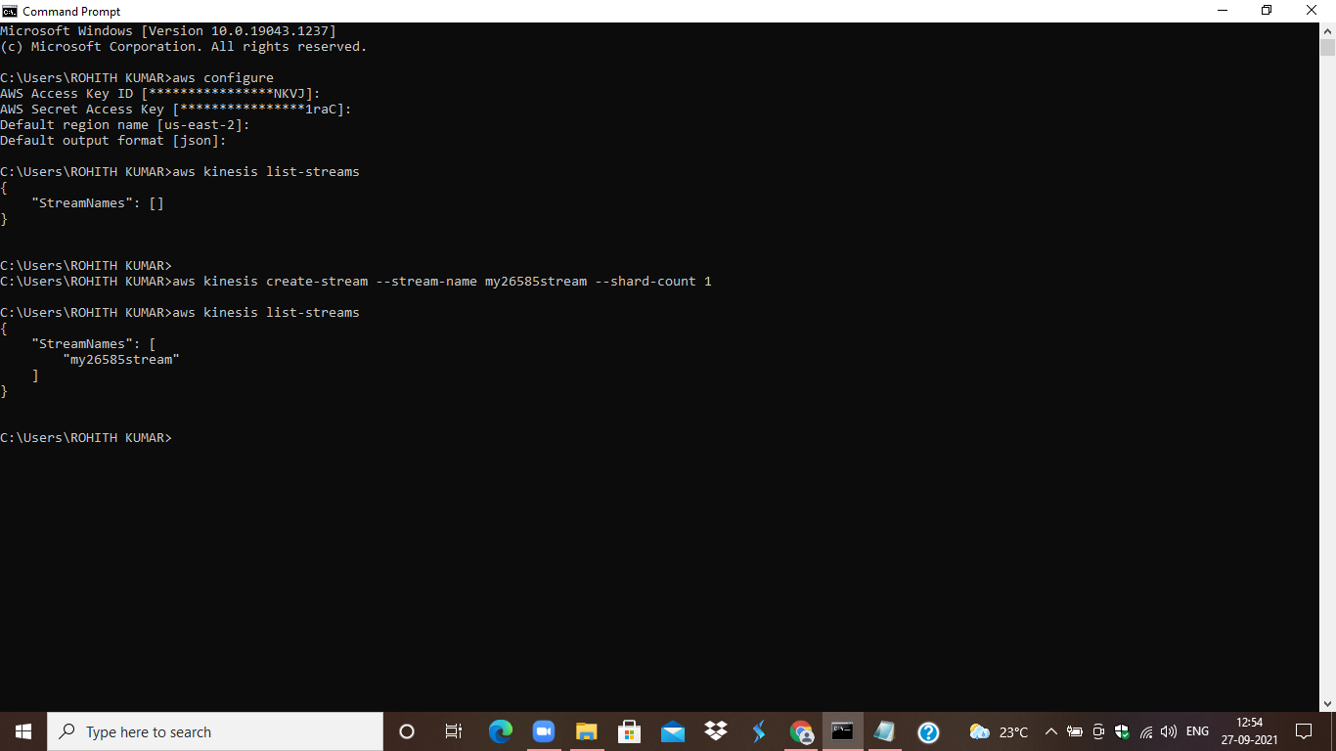

STEP1: List the streams in the kinesis using command **aws kinesis list-streams**

Create the stream by using command

**aws kinesis create-stream --stream-name my26585stream --shard-count 1**

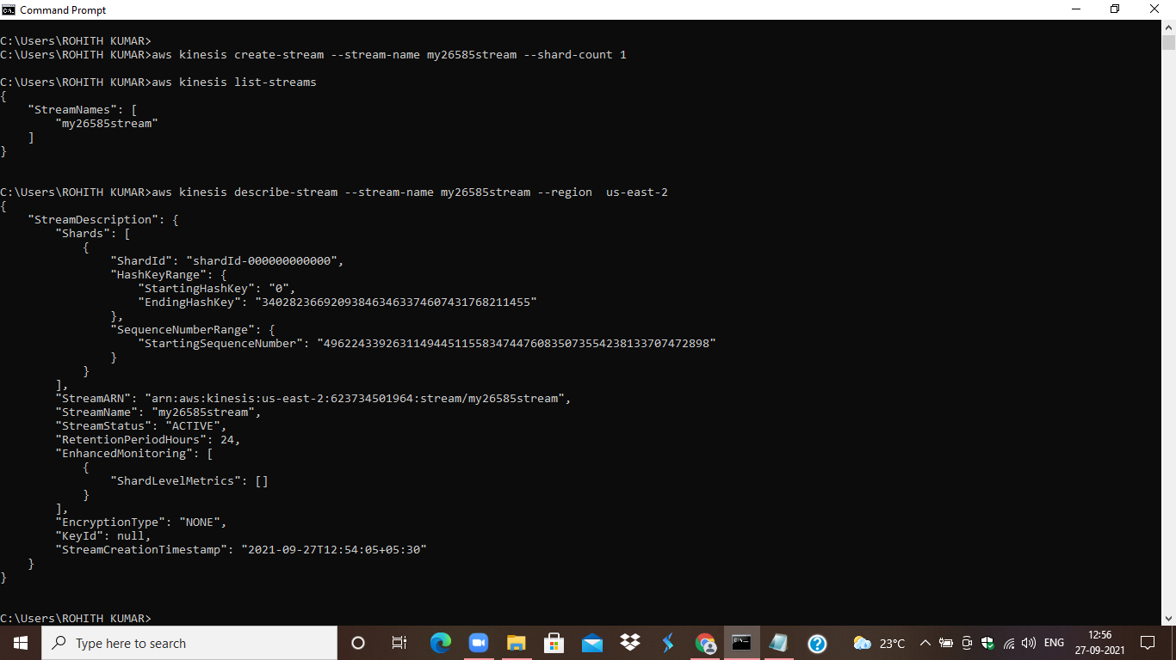

STEP2: Describe the stream using **aws kinesis describe-stream --stream-name my26585stream --region us-east-2**

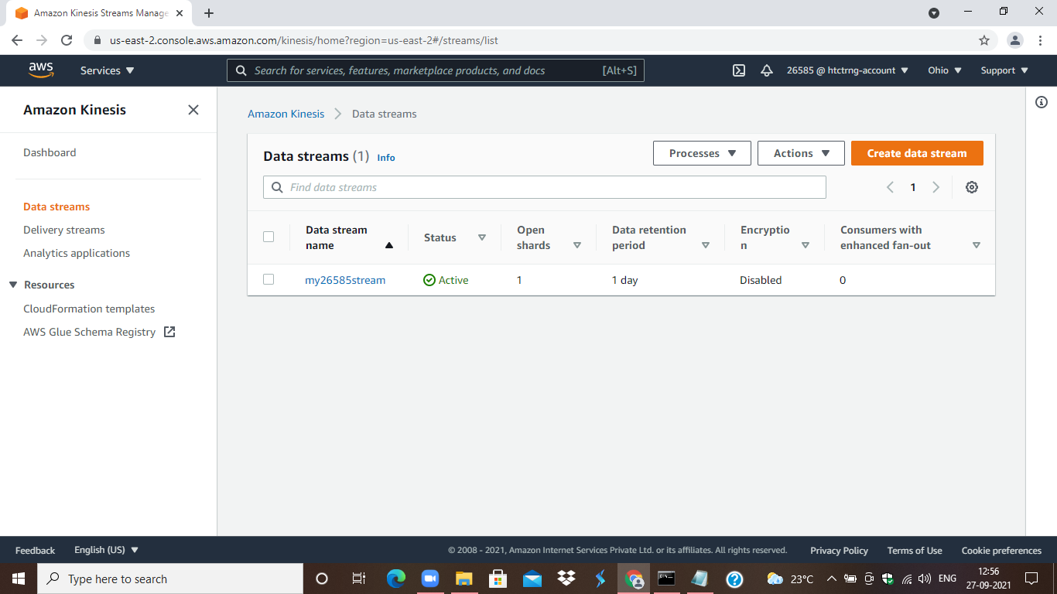

STEP3: Check whether the stream is created or not in the console.

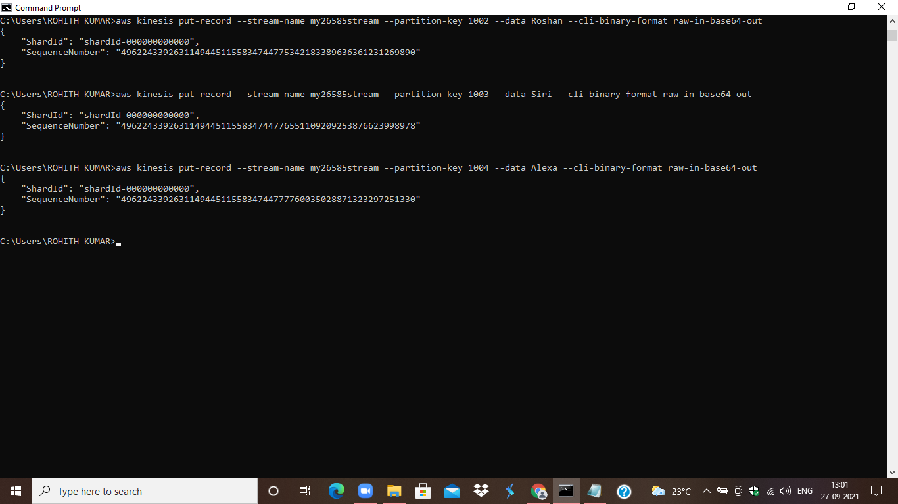

STEP4: Put the records into the stream by using command.

**aws kinesis put-record --stream-name my26585stream --partition-key 1001 --data RohithKumar --cli-binary-format raw-in-base64-out**

by giving partition key and data.

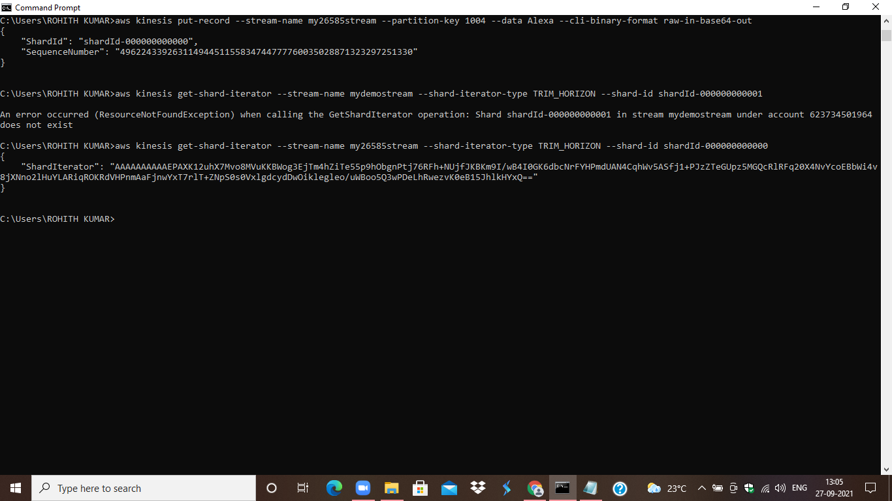

STEP5: Create the shard iterator by using command

**aws kinesis get-shard-iterator --stream-name my26585stream --shard-iterator-type TRIM_HORIZON --shard-id shardId-000000000000**

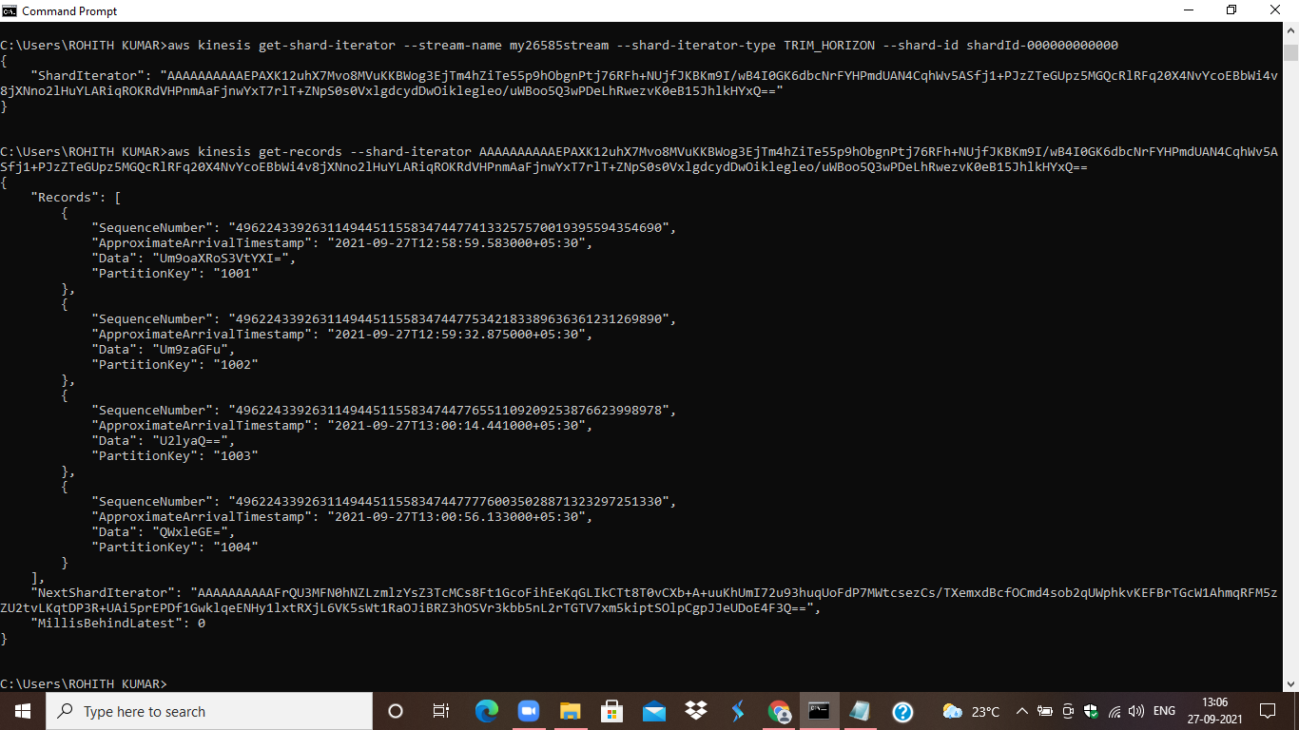

STEP6: Get the records of shard by using this iterator use the command

**aws kinesis get-records --shard-iterator <copypasteiterator> --limit 3**

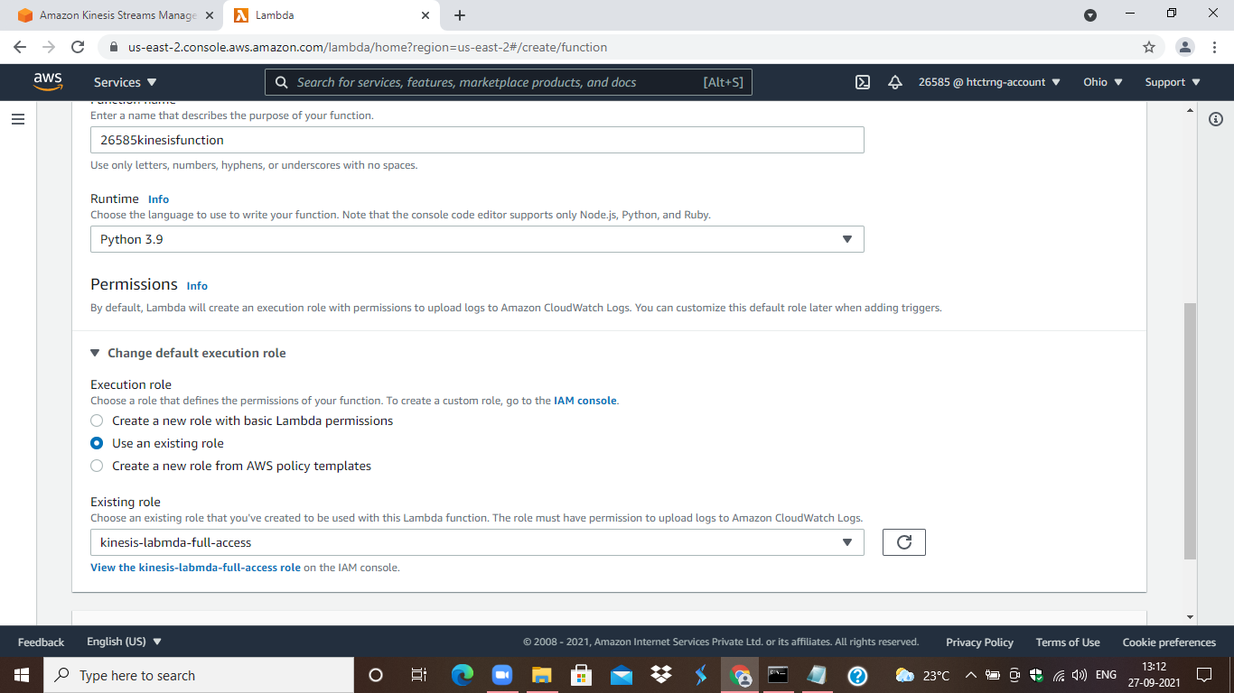

STEP7: Create a lambda function to view that records by triggering kinesis through python code.

KinesosRole aws-lambda-full-access:

awskinesisfullaccess

awscloudwatchfullaccess

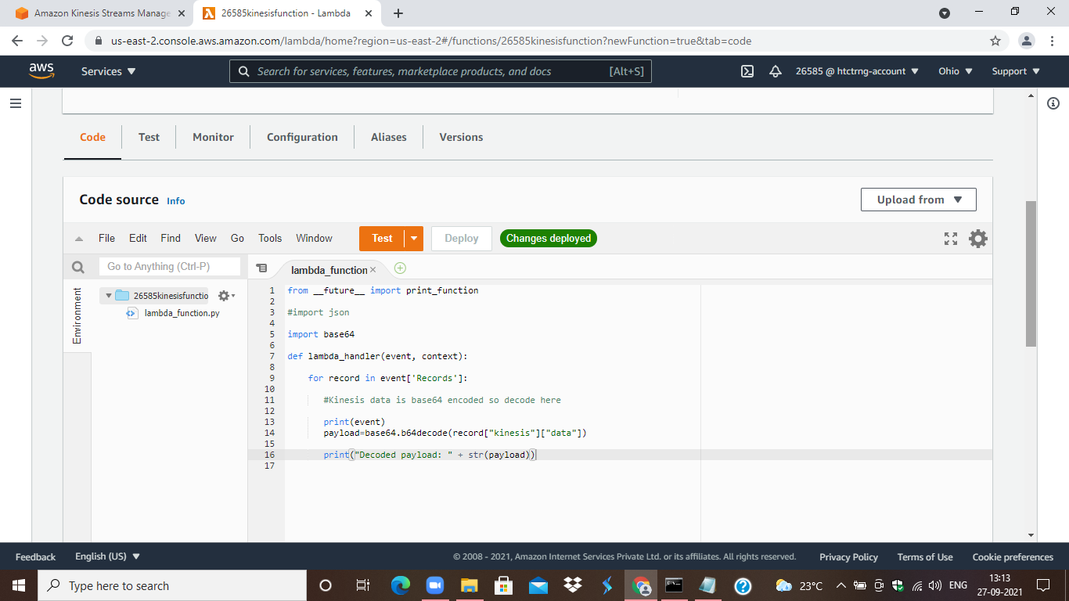

STEP8: Write the python code and create the empty test event to test.

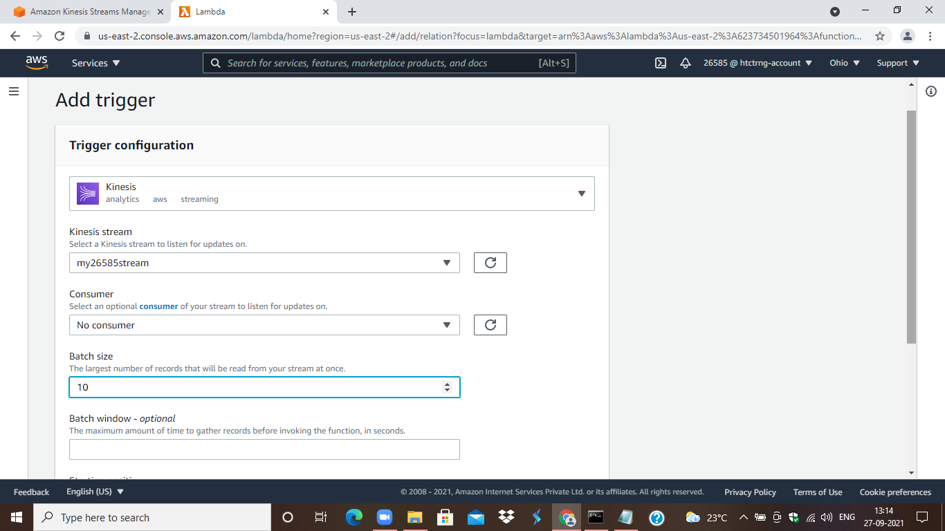

STEP9: Add trigger Kinesis, give the stream. Click on the test.

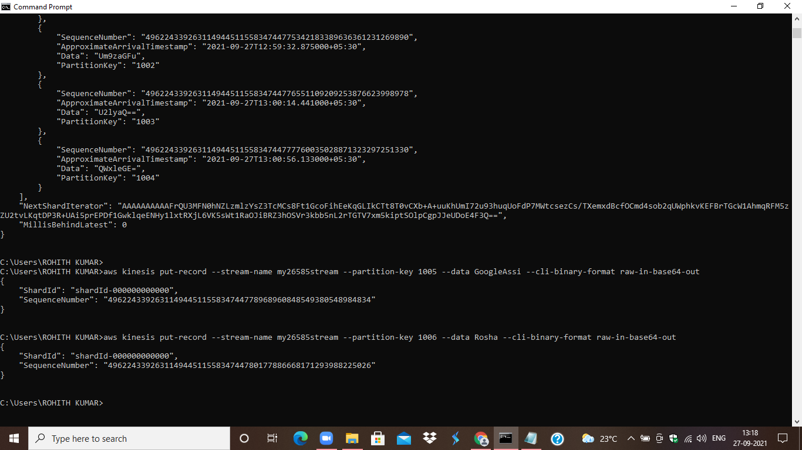

STEP10: Put the records to shard to test the triggered kinesis.

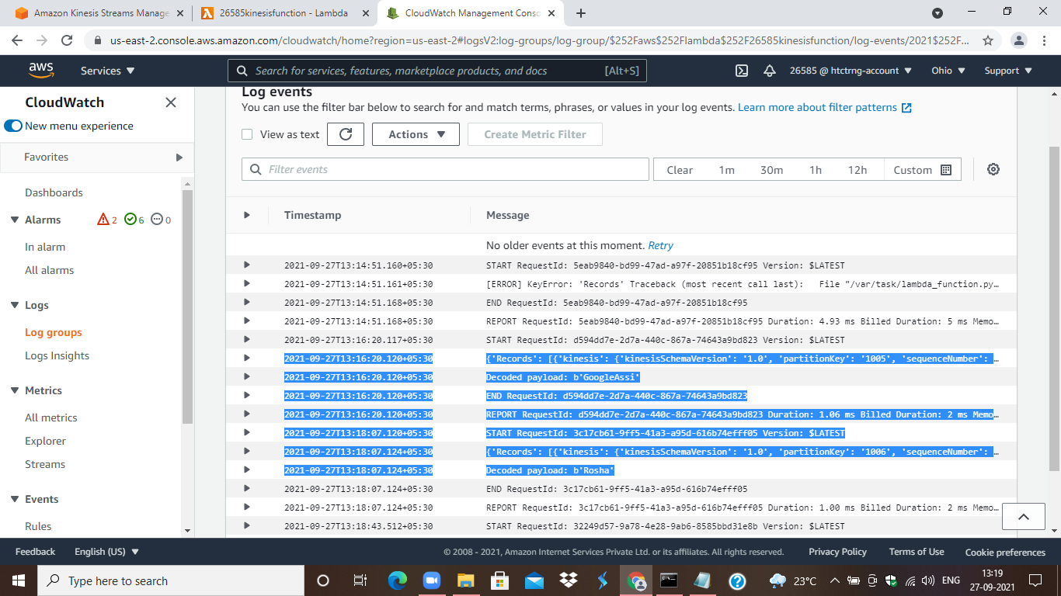

STEP11: Check the cloudwatch log group of the respective lambda function to view the records that are added.

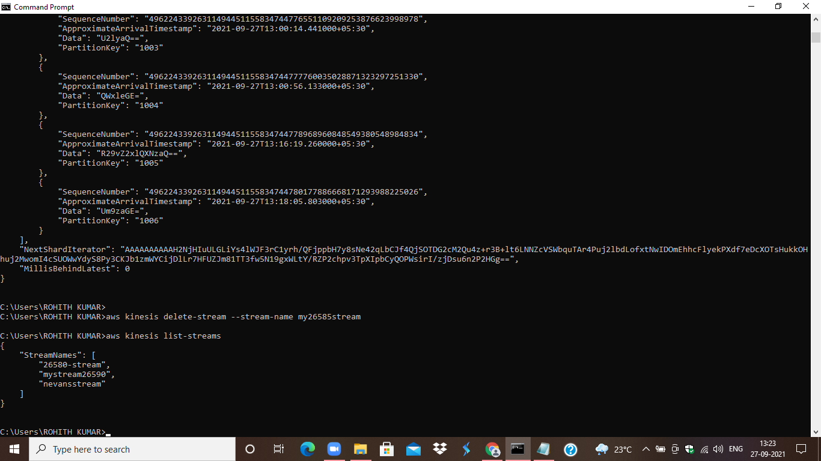

STEP12: Delete the Stream using the command

**aws kinesis delete-stream --stream-name my26585stream.**

**from __future__ import print_function**

#import json

import base64

def lambda_handler(event, context):

for record in event['Records']:

#Kinesis data is base64 encoded so decode here

print(event)

payload=base64.b64decode(record["kinesis"]["data"])

print("Decoded payload: " + str(payload))